caBIG® Integration Hub Requirements and Specification

Version No: 2.2

Last Modified: 5/12/2010

Author : Charles Griffin
Team : caBIG® Integration Hub

Client : National Cancer Institute - Center for Bioinformatics,
National Institutes of Health,
US Department of Health and Human Services

DOCUMENT CHANGE HISTORY
Version Number | Date | Contributor | Description
1.0 | 07/07/06 | Charles Griffin | Initial Draft
1.0 | 07/27/06 | Charles Griffin | Added additional requirements based on feed back from Hub SIG review and added Use Case Mappings
1.0 | 08/24/06 | Charles Griffin | Added additional requirements and made formatting modifications based on feedback from Christo and the Booz Allen Hamilton team
1.0 | 9/08/06 | Smita Hastak | Added iteration numbers to each of the requirement as requested by BAH and Christo A
1.1 | 2/20/07 | Charles Griffin; Smita Hastak | Added Requirements from the CTMSI Project – sections 1.1; 1.1.4; 3.1; 3.1.6;
1.2 | 9/26/07 | Kalpesh S. Patel | Modified document for phase II requirements
1.2 | 10/3/2007 | Michael Holck | Reformatted document and revised content
1.2 | 10/15/2007 | Kalpesh S. Patel | Modified to accommodate new template requirements
1.2 | 10/31/2007 | Eric Chen | Updated HL7 v3 data type requirements
1.3 | 12/10/2007 | Michael Holck | Updated to address comments from John Koisch
1.4 | 12/12/2007 | Kalpesh S. Patel | Modified to include appropriate release information
1.5 | 12/12/2007 | Jennifer Brush | Moved ‘future’ requirements to future requirements sections by application.
1.6 | 1/8/2008 | Bill McCurry | Added requirements for HL7 v3 data types, reformatted tables for consistency, and credited America On Top.
1.7 | 1/14/2008 | Michael Holck | Updated requirements based on CCTS requirements
1.8 | 1/31/2008 | Michael Holck | Updated to address comments
1.9 | 2/2/2008 | Michael Holck | Updated with latest requirements and links to documents
2.0 | 2/15/2008 | David Dorman | Updated use case information
2.0 | 8/15/2008 | Jennifer Brush | Updated, revised and edited for v1.5 release of CCTS
2.0 | 08/10/2009 | Harsh Marwaha | Updated, revised for v2.0 release of caXchange/CCTS
2.0 | 09/21/2009 | Amit Srivastava | Updated to reflect the name change from caXchange to caBIG® Integration Hub.
2.1 | 3/30/2010 | Harsh Marwaha | Updated for v2.1 release of caBIG® Interation Hub
2.2 | 5/13/2010 | Harsh Marwaha | Added the use case diagrams and the requirements for release 2.2
2.2 | 6/10/2010 | Harsh Marwaha | Updated based on Jessica Pritchards review

TABLE OF CONTENTS
caBIG® Integration Hub Requirements and Specification 1
Version No: 2.2 1
Last Modified: 5/12/2010 1
1 Background 5
2 Introduction 6
2.1 Document Overview 6
2.2 SCOPE 6
2.2.1 The caBIG Integration Hub ESB 7
2.2.2 Vision 8
2.3 Related documents 9
2.4 Application System Diagram 9
2.5 Release Overview 10
2.6 Definitions 11
3 caBIG® Integration Hub requirements 12
3.1.1 Constraints 12
3.1.2 Qualification Provision 13
3.1.3 Assumptions 13
3.1.4 Dependencies 13
3.1.5 Security 14
3.1.6 Environment 14
4 Application Functional Requirements 15
4.1 caBIG® Integration Hub solution Requirements 15
4.1.1 caBIG® Integration Hub Use Cases 15
4.1.2 caBIG® Integration Hub Components 17
Glossary 22

Background
The overall goal of caBIG® Integration Hub is to build a hub system that can be adapted and extended to multiple data formats and whose value and usability can be applied in one or more cancer centers. Because caBIG® program is the primary sponsor, all work performed for Integration Hub must comply with the caBIG® principles of open source, open development, open access, and federation. Software used and/or developed in the context of this project must be caBIG® compatible at the silver level. The caBIG® compatibility guidelines can be found here:
(https://cabig.nci.nih.gov/guidelines_documentation/caBIGCompatGuideRev2_final.pdf).
Table 1 below defines the key roles in Integration Hub:
Table 1 Key caBIG Integration Hub Project Roles
Role | Name | Comments
Project Sponsor | caBIG®
Reviewer | caBIG® Architecture Workspace | Reviews and provides guidance of architecture artifacts
Reviewer | caBIG® Clinical Trials Suite Architecture Team | Provides requirements
User | NCICB | Hosts the hub
Developer | Ekagra Software Technologies | Develops the application

The caBIG® Integration Hub Solution consists of multiple distributed components, which Table 2 provides, along with each component’s respective location.
Table 2 caBIG® Integration Hub Components
Component | Hosting Site | Comments
caBIG® Integration Hub ESB | NCICB | The hub and all auditing and logging
caBIG® Integration Hub Inbound Grid Service,  caBIG® Integration Hub Consumer Service. | NCICB | The caBIG® Integration Hub component enabling integration in the caGrid environment.
caBIG® Integration Hub Open Clinica Plugin | NCICB | The plugin that enables integration of Open Clinica with caBIG® Integration Hub

Introduction

Document Overview
This Software Requirements Specification (SRS) document captures the requirements for the software components of the caBIG® Integration Hub. The overall goal of this project is to build a hub system that implements various integration scenarios and whose value and usability can be pilot tested in one or more cancer centers.

SCOPE
The caBIG® Integration Hub project involves both technical and non-technical efforts divided amongst the groups defined in the Table 1 in Section 1. The caBIG® Integration Hub is a software component primarily responsible for receiving input from various external systems, routing this input to various services hosted on the hub, and eventually routing the output of those services to external systems.
The scope of caBIG® Integration Hub 2.2 includes continued support for the Suite and allows for the necessary extensibility to meet the long-term objectives for caBIG® Integration Hub to function as an enterprise interface engine.
caBIG® Integration Hub provides the following functionality to the caBIG® community:
- Integrate securely non-caGrid applications into the Suite caGrid environment
- Test the integration scenarios
- Validate the payload send in as part of the request ensuring that the payload is as expected
- Integrate with Person and Organization Enterprise Services
- Integrate with Protocol Abstraction Enterprise Services
- Process requests synchronously as well as asynchronously
- A transformation engine that can be configured to perform XSL transformations on the business payloads
- A notification component that can be configured to send notifications on failure
- Implement integration scenarios in a non-caGrid environment
- Comply with the NCI CBIIT Build and Deployment Automation process
- Provide a GUI-based installer to install the application
- Provide support for a mySQL, Postgres and Oracle support.
*Please note the following limitation of Postgres and Oracle support for Integration Hub 2.2: the Log Locator Tool will still require the use of a mySQL database.
This document does not address system or user related requirements that are not directly related to the caBIG® Integration Hub ESB and to the caBIG® Integration Hub Inbound Service.

The caBIG Integration Hub ESB
The caBIG® Integration Hub ESB is defined as the software component primarily responsible for receiving input from various external systems, routing this input to various services hosted on the hub, and eventually routing the output of those services to external systems. The ESB will also perform logging and auditing of all messages that pass through the hub.
As a part of this effort, the caBIG® Integration Hub ESB will reside on the NCICB servers and will be responsible for implementing the following integration scenarios:
- Receiving patient laboratory data in HL7v3 format for CT Laboratory Observation Periodic Report messages and routing the messages to the CTODS grid service.
- Receiving study creation messages in the BRIDG format from C3PR and routing it to the caAERS, PSC and CTODS grid service. Furthermore, ensuring that the applications that receive this message remain in a consistent state. A failure in one of the applications results in a rollback of the transaction in all the applications.
- Receiving the subject registration messages in the BRIDG format from C3PR and routing them to caAERS, PSC, CTODS grid service, and C3D Grid Service. Furthermore, ensuring that the applications that receive this message remain in a consistent state. A failure in one of the applications results in a rollback of the transaction in all the applications. The patient position of the subject is returned from C3D to the C3PR application.
- Receiving laboratory data in the HL7v3 format from Lab Viewer and routing it to the C3D Lab Loader service.
- Receiving laboratory data in the HL7v3 format and routing it to the caAERS application.
- Receiving adverse event notification from the caAERS application and routing it to the PSC application.
- Providing integration to the Person and Organization services hosted on the NCICB servers. Suite applications will integrate with these services for the Person and Organization data. The service hub will provide additional functionality as needed by the Suite applications to invoke these services.
- Providing integration to the Protocol Abstraction enterprise services hosted on the NCICB servers. Suite applications will integrate with these services for Study Protocol data. Additionally the service hub will provide additional functionality as needed by the Suite applications to invoke these services.
- Providing integration with the caTissue application for the createParticipant and createSpecimen operations. The integration with the caTissue application should be extensible for implementing additional integration scenarios.
- Including a test suite that will enable testing of the various integration scenarios in a caBIG® Integration Hub deployment.
- Providing a GUI-based installer using the NCI Build and Deployment Automation framework templates for GUI installers.
- Documenting the specifications for the message service and the notification management service based on the Enterprise Conformance and compliance framework (ECCF).
As part of the Suite, caBIG® Integration Hub will be responsible for implementing any additional integration scenarios and should provide for flexible deployment and configuration options where an integrated application or component can be removed and another component or application be added. For example, when a Suite deployment at a cancer center requires the use of a CTMS other than C3D; in such a deployment, caBIG® Integration Hub should be configured to route the appropriate messages to the cancer center CTMS rather than C3D.
The caBIG® Integration Hub software should comply with the NCI CBIITs Build and Deployment Automation infrastructure.

Vision
Clinical laboratory systems in cancer centers often have an interface that supplies laboratory data in the form of HL7v2.x messages. It is also possible that some clinical laboratory systems can only supply data in comma delimited or other file formats or that the local healthcare system’s information service’s organization chooses to provide information in such a manner. Likewise, various clinical trials management systems may accept data in multiple formats. Integration Hub’s interest is in providing infrastructure to support implementation of integration scenarios in the clinical trial space. Currently, cancer centers desiring integration among their clinical trial related software products are faced with an expensive project to custom-build an interface between the two systems. Because of the heterogeneous nature of clinical trial software systems, it is not expected that the local integration efforts to provide the appropriate message syntax at cancer centers can be reduced to zero, but minimizing local development work is highly desirable.
Integration Hub will focus on the development of an open-source, caBIG® compatible solution to support the exchange of laboratory data collected during a clinical trial. The resulting solution must stand alone and be Silver level compatible.

System Component Identification
The following sub-sections identify the components addressed in this document.

Software
Table 3 Project Software
Title | Abbreviation | Release #
caBIG® Integration Hub ESB | ESB | 2.2
caBIG® Integration Hub Inbound Request Processor Service | caBIG® Integration Hub Request Processor | 2.2
caBIG® Integration Hub Generic Consumer Service | caBIG® Integration Hub Consumer | 2.2
caBIG® Integration Hub OpenClinica Plugin | OpenClinica Plugin | 2.2
OpenClinica webSSO Client | OpenClinica webSSO Client | 2.2

Documentation
Table 4 Project Documentation
Title | Abbreviation | Release #
Technical Architecture Guide | N/A | 2.2
Installation Guide | Install Guide | 2.2
Administrative Guide | Admin Guide | 2.2

It is important to note that the scope of this release does not provide documentation for any of the COTS or open source products utilized in the caBIG® Integration Hub. To obtain documentation on these products, users or developers should go to the website that hosts the particular product of interest to retrieve the desired documentation. The following section provides links to Integration Hub’s documentation.

Related documents
Table 5 Related Documents
Document Name | Location
caBIG® Integration Hub Use Case Specification and Realization Documents | https://ncisvn.nci.nih.gov/svn/cabigintegrationhub/trunk/docs/Requirements/
caBIG® Integration Hub Design Document | https://ncisvn.nci.nih.gov/svn/cabigintegrationhub/trunk/docs/Design/
caBIG® Integration Hub Technical Architecture Guide | https://ncisvn.nci.nih.gov/svn/cabigintegrationhub/trunk/docs/Design/
caBIG® Integration Hub Installation Guide | https://ncisvn.nci.nih.gov/svn/cabigintegrationhub/trunk/docs/installation/
caBIG® Integration Hub Interface Specification | https://ncisvn.nci.nih.gov/svn/cabigintegrationhub/trunk/docs/Interface/

Application System Diagram
The diagram below depicts the various components of the caBIG® Integration Hub effort, along with some of the external systems with which caBIG® Integration Hub will interact.
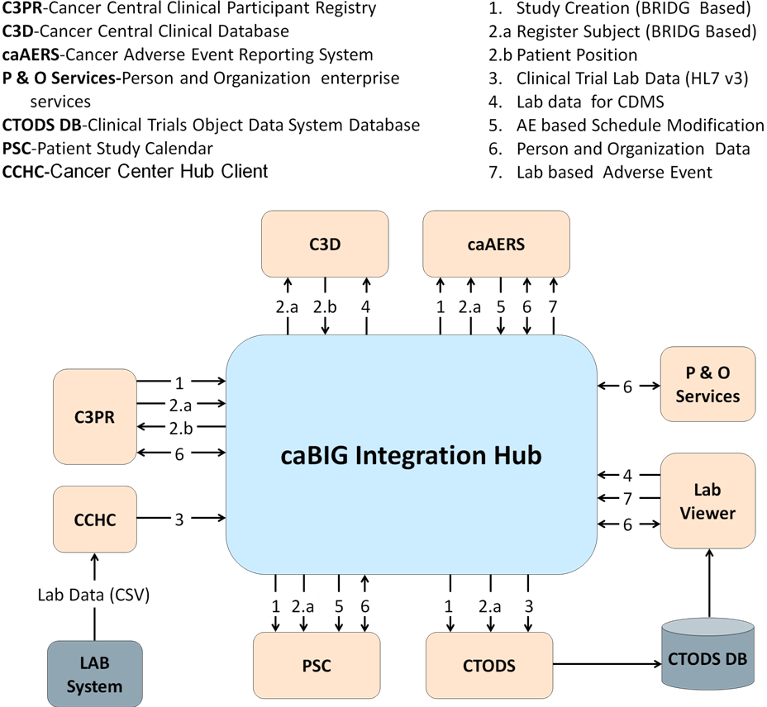
Figure 1 caBIG Integration Hub Application System Diagram

Release Overview
Table 6 Project Release Information
Release | Date Released | Version comments
0.5 | 2/20/2007 | Released as Lab Hub
1.0 | 2/14/2008 | Will be a part of the Suite 1.0 release
1.5 | 10/30/2008 | Will be a part of the Suite 1.5 release
2.0 | 09/30/2009 | Will be a part of the Suite 2.0 release
2.1 | 03/31/2010 | Will be a part of the Suite 2.1 release
2.2 | 08/02/2010 | Will be a part of the Suite 2.2 release

Definitions
Developers and Adopters must clearly understand the following definitions and agree upon the ranking used with any given requirement.
MUST – The requirement definition is an absolute postulation of the specification.
MUST NOT – The requirement definition is an absolute prohibition of the specification.
WILL – The requirement definition is an absolute future requirement of the specification.
WILL NOT – The requirement definition is an absolute future prohibition of the specification.
SHOULD - This word means that there may exist valid reasons in particular circumstances to ignore a particular item, but the full implications must be understood and carefully weighed before choosing a different course.
SHOULD NOT - This phrase means that there may exist valid reasons in particular circumstances when a behavior is acceptable or even useful, but the full implications should be understood and the case carefully weighed before implementing any behavior described with this label.
MAY – A requirement is truly optional, so the developer may choose to include the item based on the needs of their design.

caBIG® Integration Hub requirements
User/system requirements derive from the original Laboratory Information Integration Hub Statement of Work. Additional requirements are derived from enhancements for CTMSi, the SOW for Phase III of caBIG® Integration Hub, and the kick-off meeting and project plan for the Phase IV of caBIG® Integration Hub. Requirement gathering meetings with project stakeholders provide additional requirements. These stakeholders include the following:
- CTMS Study Conduct SIG
- Suite architecture team
- NCICB Product Management
Additional requirements will be gathered during the review of this document’s draft, as well as during the initial design phase of the various caBIG® Integration Hub components.
The requirements can be grouped into two major categories:
- Software, which includes the requirements for each of the components being developed by the caBIG® Integration Hub technical team that comprise the end to end technical solution
- Documentation, which includes a description of the various documentation artifacts that are expected to be produced by the caBIG® Integration Hub team during the version 2.2 release.

Constraints
Below are the constraints that apply to the caBIG® Integration Hub software engineering options:
- The software components utilized in this solution must be open source and freely distributable.
- The software components utilized in this solution should adhere to the existing technology stack of the environments in which they will be deployed.
- The solution must meet the HIPAA privacy standards.
- The solution must adhere to technical and operational principles of the caBIG® program.

Qualification Provision
This section defines a set of qualification methods and specifications for each of the requirements, as well as the method(s) to be used to ensure that the requirement has been met.
Table 7 Qualification Requirements
Qualification Method | Description | Requirements
Demonstration | The operation of the system or component that relies on observable functional operation not requiring the use of instrumentation, special test equipment, or subsequent analysis.
Test | The operation of the system or component using instrumentation or other special test equipment to collect data for later analysis.
Analysis | The processing of accumulated data obtained from other qualification methods. Examples are reduction, interpretation, or extrapolation of test results.
Inspection | The visual examination of code, documentation, etc.

Assumptions
The following are assumptions of caBIG® Integration Hub and its related software components:
- The NCICB hosted components will be deployed in the shared production NCICB environment.
- The project components will adhere as closely as possible to the published NCICB Future Technology Stack.
- The caCORE and caBIG® products utilized in this solution are expected to perform their proposed functionality. If there are any product defects, they will be fixed by the respective product team and not the caBIG Integration Hub development team.
- If the appropriate versions of the proposed products that are expected to be used in this solution are not available, a work around must be implemented by the caBIG® Integration Hub team; however, the caBIG® Integration Hub team will not write replacements for those products.
- ServiceMix 3.3.1 will be used for this caBIG® Integration Hub release.

Dependencies
The following are dependencies of the caBIG® Integration Hub and its related software components:
- The C3PR grid service provided by C3PR R2 will be utilized to formulate the HL7v3 messages with additional identifier information.
- The caGrid Security Infrastructure including the caGrid Delegation Service, the sync GTS service, will be used to implement the security for the caBIG Integration Hub in a caGrid environment.
- The caGrid Global Model Exchange GME service can optionally be used as repository of XML Schemas, which define the structure of messages flowing through caBIG Integration Hub.
- The BRIDG Clinical Analysis Models (CAM) will be used to generate the BRIDG-based messaging objects.
- The build and deployment of the caBIG® Integration Hub will use the templates from the NCI CBIITs Build Deployment Automation project.

Security
The prior release of caBIG® Integration Hub utilized the NCICB CSM product for authentication and authorization. In this v2.2 release the Grid Authentication and authorization technology is used to accept a user’s grid credentials for authentication and authorization.
The Credential Delegation Service and other caGrid authentication infrastructure will be utilized and caBIG® Integration Hub will integrate for user level authentication and authorization. The caBIG® Integration Hub will also provide a WS-Security-based mechanism for authenticating in a non-caGrid environment and a mechanism to propagate credentials to target services so that the target services can be invoked securely.

Environment
All caBIG® projects must be platform and database-independent applications, so caBIG® Integration Hub should run on any operating system and support any database.
Table 8 below details the environment that should be used for testing caBIG® Integration Hub.
Table 8 System Environment
Operating system | Linux/Windows XP
Database | MySQL 5.0.45/Postgre 8.2.11/ Oracle 10.2
Browser | Not Applicable
Java | 1.5.0_10 SDK
Container | ServiceMix 3.3.1 and Tomcat 5.5.27
Ant | 1.7
Maven | 2.0.9
caGrid | 1.2

Application Functional Requirements

caBIG® Integration Hub solution Requirements
The following sections describe the requirements for all three caBIG® Integration Hub components.

caBIG® Integration Hub Use Cases
caBIG® Integration Hub use cases are described in detail in separate use case documents. The latest versions of these documents can be found at:
https://ncisvn.nci.nih.gov/svn/cabigintegrationhub/trunk/docs/Requirements/
The diagram in figure 2 below depicts the use cases and actors for the caBIG® Integration Hub. The main client interactions with the caBIG® Integration Hub include processing request asynchronously/synchronously, and retrieving request response. The other use cases such as payload validation, credential retrieval etc may be included in these use cases based on the needs of the integration scenario.
The use case diagram in Figure 2 below is available caBIG® Integration Hub design EA project. The latest version of this EA project file can be found at:
https://ncisvn.nci.nih.gov/svn/cabigintegrationhub/trunk/docs/Design/caBIG%20Integration%20Hub%20Design.eap

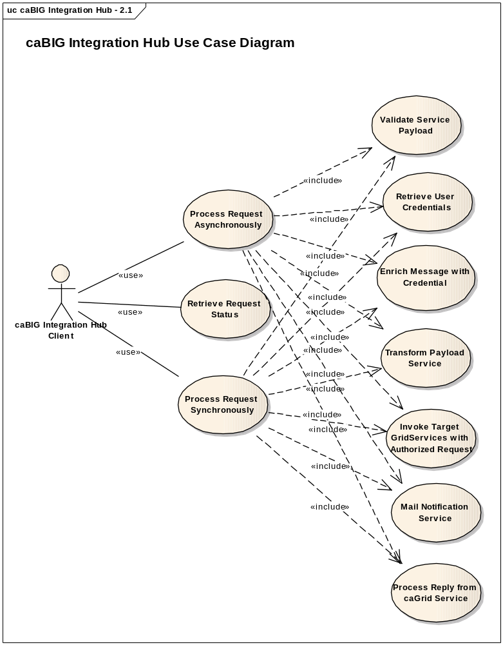
Figure 2 caBIG® Integration Hub use cases
The following diagram illustrates the caBIG® Integration Hub use cases for routing configuration. These use cases outline the hub functionality required for configuring new integration scenarios and updating existing integration scenarios to add or remove services.
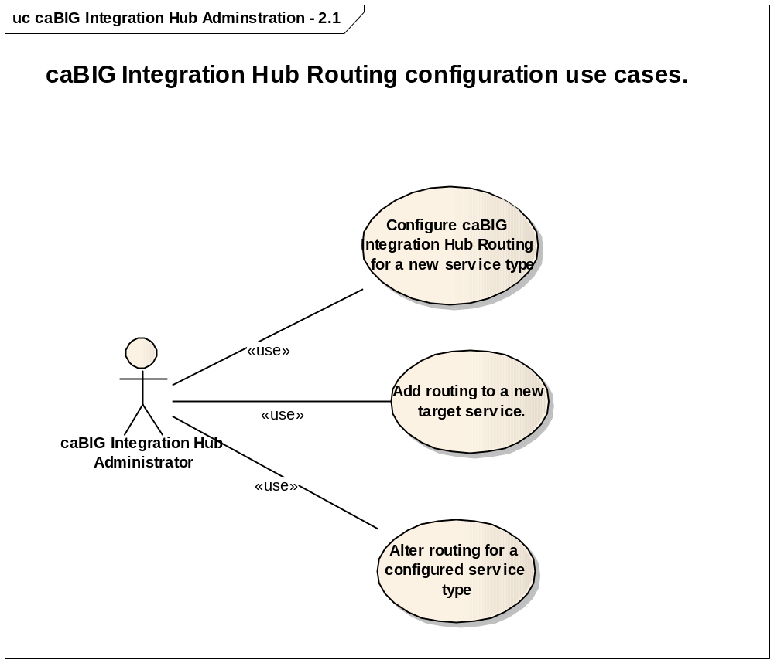
Figure 3 caBIG® Integration Hub Administration use cases

caBIG® Integration Hub Components
This section describes the requirements for the caBIG® Integration Hub component of the caBIG® Integration Hub Solution, which Table 9 documents below.
Table 9 caBIG® Integration Hub Component Requirements
GForge ID | Requirement Type | Requirement Details | Release # | Use Case ID | Product
14149 | System | Compare JBoss ESB and Servicemix ESB for caBIG® Integration Hub requirements | 1.5 |  | ESB
14142 | System | The caBIG® Integration Hub ESB must provide the ability to externalize the routing configuration | 1.5 | caBIG® Integration Hub-Routing-Metadata-Service-UseCase | ESB
14144 | System | The caBIG® Integration Hub ESB should validate the input payload against the  schema URI provided before sending the message for further processing | 1.5 | caBIG® Integration Hub Validation Framework Usecase | ESB
22800 | System | ServiceMix clustering capabilities must be deployed and tested to show enterprise scalability | 1.5 |  | ESB
14146 | System | Support itinerary based routing | Future |  | ESB
14175 | System | Register updated caBIG® Integration Hub Interface model in caDSR | 2.0 |  | ESB
22519 | System | caBIG® Integration Hub to provide a Mail Notification Component. This component can be used to configure mail notifications. Subscribers can be notified on failure/success of requests or for other conditions. | 2.0 | caBIG® Integration Hub Mail Notification Framework Usecase | ESB
22682 | System | caBIG® Integration Hub Inbound Grid Service is currently deployable as a caGrid Service on a Tomcat Container. This requirement is to ensure that the service is deployable on a JBoss container in compliance to the NCI CBIIT Technology Stack. | 2.0 |  | ESB
22684 | System | caBIG® Integration Hub needs to provide an XML to XML transformation service. This component can be used to configure Extensible Stylesheet Language Transformations (XSLT) for messages through caBIG® Integration Hub. | 2.0 | caBIG® Integration Hub Transformation Framework Usecase | ESB
22798 | System | caBIG® Integration Hub build and deployment scripts need to conform to the NCI CBIIT Build and Deployment Automation (BDA) framework. | 2.0 |  | ESB
22799 | System | caBIG® Integration Hub needs to provide for integration scenarios in a non caGrid environments. Clients should be able to invoke caBIG® Integration Hub securely through a web services interface. | 2.0 |  | ESB
22801 | System | caBIG® Integration Hub needs to provide integration with the COPPA Person and Organization services to make them available for CCTS | 2.0 |  | ESB
22802 | System | caBIG® Integration Hub needs to provide integration with the COPPA Protocol Abstraction services to make them available for CCTS. | 2.0 |  | ESB
14258, 22698,  22699 | System | Upgrade the products / technologies used in the caBIG® Integration Hub to match the NCICB technology stack | 2.0 |  | ESB
27694 | System | caBIG® Integration Hub will provide integration with secure COPPA services. | 2.1 |  | ESB
27695 | System | caBIG® Integration Hub will provide integration with PO Business services | 2.1 |  | ESB
27696 | System | caBIG® Integration Hub will provide integration with Generic Clinical Connector | 2.1 |  | ESB
28548 | System | caBIG® Integration Hub shall provide support the unified security architecture and deployment of caBIG Clinical Trials Suite | 2.2 |  | ESB
28546 | System | caBIG® Integration Hub shall provide support for the postGres database. Hub postgres support will be limited for the Hub schema, ActiveMQ schema and for CSM schema. CLM schema will still be installed in mySQL because of LLT limitations | 2.2 |  | ESB
28545 | System | caBIG® Integration Hub will provide a GUI based installer | 2.2 |  | ESB
14150 | System | caBIG® Integration Hub – provide ability to integrate with legacy CDMS systems | Future |  | ESB
14143 | System | Provide ability to notify client applications when updating the status of their message request | Future |  | ESB
14145 | System | Provide an HL7 v2 to v3 transformation service. The caBIG® Integration Hub can provide a pluggable service for transforming messages from Hl7v2 to HL7v3 using caAdapter APIs. | Future |  | ESB
14147 | System | Provide client applications with a mechanism for discovering the endpoints and services that are registered on caBIG® Integration Hub | Future |  | ESB
14124 | System | caBIG® Integration Hub – integrated with PostGres database | Future |  | ESB
14173 | System | caBIG® Integration Hub to Integrate with Lab Grading applications | Future |  | ESB
14174 | System | caBIG® Integration Hub to provide an integrated BRIDG based data query service. | Future |  | ESB
TBD | System | The system must ensure that transformation service is available on the caBIG® Integration Hub such that future transformations can be plugged in (such as HL7v3 - BRIDG, or HL7v3 to Oracle-HTB) | Future |  | ESB
TBD | System | The system must audit the occurrence of invalid messages from the transformation service to a audit/log data store. | Future |  | ESB
TBD | System | The system will provide an audit summary of the transformation process. The audit should provide a count of records that were processed successfully and unsuccessfully. The audits should list the MRN’s of the records that were processed successfully and unsuccessfully. | Future |  | ESB
TBD | System | The system must be able to receive an HL7v3 message instance for each trial( when a patient belongs to multiple trials). The lab data will eventually be persisted for every trial the patient belongs to. | Future |  | ESB
TBD | System | If the Audit/Log Service receives a message with a “fatal” alert level, the service will notify the Hub Administrator or other support personnel of the fatal conditions via e-mail | Future |  | ESB
TBD | System | The system will develop a way for non-Grid Services to be advertised on the Grid’s Index Service so that they can be discovered and used by Grid clients and Grid Services | Future |  | ESB
TBD | System | A message exchange framework based on the BRIDG model (similar to an HL7 XML ITS based on the RIM) to implement the wire-format for CCTS messages must be developed. The message structures will be developed and managed in conjunction with the CCTS Analyst team. | Future |  | ESB
TBD | System | The caBIG® Integration Hub Administrator must be given the opportunity to view caBIG® Integration Hub performance via a GUI console | Future |  | ESB
TBD | System | The caBIG® Integration Hub Administrator must be given the ability to see if services on the caBIG® Integration Hub are installed, uninstalled, or running. | Future |  | ESB
TBD | System | The caBIG® Integration Hub Administrator must be given the ability to view the number of messages a service on the caBIG® Integration Hub has received. | Future |  | ESB
TBD | System | The caBIG® Integration Hub Administrator must be given the ability to view the number of messages a service on the caBIG® Integration Hub has sent out | Future |  | ESB
TBD | System | The caBIG® Integration Hub Administrator must be given the ability to view the number of inbound messages a service receives per second. | Future |  | ESB
TBD | System | Provide the ability for a hub administrator to define workflow for a message utilizing BPEL. | Future |  | ESB
TBD | System | Provide a reusable, generic service on the caBIG® Integration Hub that can be used to execute multiple workflows defined in BPEL. | Future |  | ESB
TBD | System | Provide ability to route the invalid messages from the transformation service back to the cancer center | Future |  | ESB
TBD | System | Provide WS-Notification based framework for notifying request senders of the status of the message | Future |  | ESB

Glossary
Table 9 SRS Glossary
Term | Definition
NCICB | National Cancer Institute Center for Bioinformatics
BPEL | Business Process Execution Language
C3PR | Cancer Central Clinical Participant Registry
caAERS | Cancer Adverse Event Reporting System
GUID | A unique ID that the Enterprise Architect product assigns to each object that is created by the tool.
CCHC | Cancer Center Hub Client. The software that is responsible for sending patient laboratory data to the Lab Hub via an interface exposed by the HUB
LIH | Laboratory Information Integration Hub
Endpoint | A destination to which the hub can route data to. An endpoint can represent a service deployed on the hub or an external system to which the hub routes data.
CTMSI | Clinical Trials Management System Interoperability
CCTS | Cancer Clinical Trials Suite

